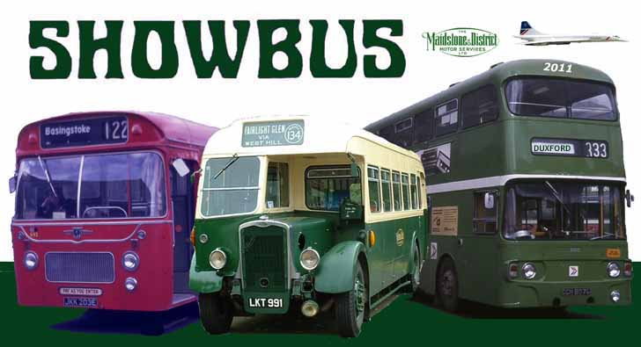
TTCDiecast presents this year’s SHOWBUS international:
a projected colourful display of around 500 buses and coaches, 100 stalls and a crowd of around10 000. Founded in 1973, this will be our 39th display.

There is a special commemoration of Maidstone & District’s centenary with an on-site parade of M&D associated vehicles at noon around the time the last entrants arrive.

We will be celebrating many other anniversaries including 50 years
of the Alexander Y-type and London RML Routemaster and 60 years of the London RF.

Thanks to our sponsors the event features loads of prizes comprising a mixture of cash from D&G Bus, presentation models,
trophies and souvenir Go-Ahead rally plaques for all entrants. Favourable admission arrangements for entrants give access to Europe's biggest and best aircraft museum as well as the world's biggest and best bus and coach display. The added attraction of the huge stallholders' market provides opportunities not only to buy regular models amongst the diverse selection of bus paraphernalia, but also to acquire the special models associated with the rally which comprise a SHOWBUS version of the Jotus model of the unique London FRM and will be showcasing their new release program for future commissions and brand new projects for 2011/12.

Two new attractions this year are our mini-trade show in front of the American Air Museum (contact us in order to book a space)
SHOWBUS Showcase
a display buses from the Alexander-Dennis Enviro range

The Duxford site provides unrivalled facilities for enthusiasts, exhibitors, their families and the public. You may see military vehicle demonstrations and historic aircraft flying.

TTCDiecast’s SHOWBUS international welcomes enthusiasts and buses from around the world.

A popular SHOWBUS attraction is the tours of Duxford Village. If your vehicle is suitably taxed and insured and you would like to do a tour, please fill in the appropriate section on the entry form. We are also looking for volunteers to operate the on-site shuttle bus to provide a 15 minute disabled access shuttle plus doubledeckers to provide mobile grandstand views. An additional attraction this year is a trip to view the new Cambridge Busway, which might actually be open by September. We have also reintroduced the Whittlesford Shuttle to make for quicker access to Duxford. Please let us know if you would like to help on that too.

Access to Duxford itself is good. The site is situated at Junction 10 of the M11 near Cambridge. Nearby on the A505 the Coach House Hotel offers both motel accommodation and ample parking for buses (Tel 01763 208272). If booking mention SHOWBUS for special rates.

Please note that, because of air traffic, dogs are not allowed on the Duxford site. For safety reasons barbecues are prohibited.

Over the years, one thing stands out above all else at SHOWBUS - it is a great day out for friends and families, with plenty to see and do, and that opportunity to meet friends and acquaintances associated with Britain's bus industry from all over the country – and abroad. 'See you at SHOWBUS' is now a familiar phrase, use it and you're sure of a welcome.

SHOWBUS Committee e-mail rally@showbus.com
Phone 01494 558147 (07518 624034 SMS)
Dr Martin Isles (Entries & Parking Reception) Fax 01494 558147
Mr Dave Reid (Rally Control & judges)
6 Fair Ridge, HIGH WYCOMBE. HP11 1PL This address will cease to be used after the event
Mr Rob Passaway (Programme sales) Mr Dominic Spooner (Trade stands)
Mr Charlie Nicholson (Parking Display & Duxford tours) Mr Mark Howgego (Rally Control)

TTC Diecast’s SHOWBUS International PRIZE CATEGORIES
Preserved vehicles | Non Preserved vehicles | All vehicles
B Best Bristol or ECW bodied  C Best AEC/Park Royal  L Best Leyland  M Best MetCam/Weyman/MCW  N Best Plaxton, NCME or Duple  Z Best ex LT or LCBS  6 Best bus not included in above  Top Rally Goer vehicle at Showbus 2011 having attended the most rallies in 2011  Most improved (assuming bus judged in 2010)  Best in Show Shillibeer Award  Best Doyen double & singledeckers | D Best post 1999 Go-Ahead  A Best post 1999 Arriva bus  F Best post 1999 First bus  S Best post 1999 Stagecoach  T Best Post 2009 bus  U Best Post 2009 coach  X Best Post 2009 mini less than 34 seat  1 Best Local authority owned  2 Best local operator**  3 Best small operator**  4 Best London bus #  Premier Operator Award  For the best pair of entries  ** & # - see showbus.com for definitions | G Pre 1950 & before  H Best 1951-59 vehicle  I Best 1960-69 vehicle  7 Best 970-79 vehicle  8 Best 1980-1989 vehicle  9 Best 1990-1999 vehicle  J Best 2000-2009 vehicle  V Best overseas bus resident in UK  zero Best overseas entry  5 Best post 1999 Plaxton  Vehicles may enter for more than one class. We will select your classes of entry.



Admission arrangements
There is no separate admission charge for the bus rally.
The cheapest way to get into SHOWBUS is on a bus.
Entry to the site gives full access to the rally and all Duxford exhibits and facilities.

The person driving and up to THREE passengers on ALL BUSES entering the site will be admitted FREE of charge.

Free admissions will only be valid at the far west "SHOWBUS - BUSES ONLY" gate (Gate 1) and are only valid for those on board a bus. All other bus passengers, aged 16 and over, on board display buses will pay the same standard reduced admission rate of £8.50 per person, payable on the day at the far west "SHOWBUS - BUSES ONLY" gate (Gate 1) - the normal Duxford adult admission is £16.50, under 16s free. If you or your passengers attempt to enter the museum by other entrances, whether on board the bus or not, normal museum admission rates apply. Other visitors must enter via the normal public entrance to the Museum where they will pay the normal admission. The admission fees are retained by the Museum to maintain its collection and facilities.



All entrants will receive final joining information in early September
All entries will be acknowledged by email, enclose an s.a.e. labelled AC if you require acknowledgement by post.
If you do not receive your paperwork check the Display section at showbus.com for emergency papers.
Please send your entry form early as we cannot guarantee dispatch of admission packs in time if your entry is received less than a week before the event.

There is no closing date for entries, but entries after late August you are unlikely to be included in the Bus & Coach Buyer programme.



The SHOWBUS Airside Market
Arrangements for entrants with stalls.
All such entrants will park together in a designated area alongside the main airside strip where other stalls will be located.

Trading from or in front of your entry anywhere else on site is not permitted. There is no restriction on distributing free items from your vehicle. Stalls in the above mentioned area will be close to vehicles, but not so as to obscure them from public view.

If you wish to have a stall in the main trade area alongside the runway, then normal rates apply and you will need to request the appropriate form from Dominic Spooner at dom@showbus.com, who can also be contacted via this form’s return address:
6 Fair Ridge, HIGH WYCOMBE. HP11 1PL

Only items of transport interest may be sold and the organisers reserve the right to ban the sale of certain items on the day. Undercover accommodation is not available. To avoid mess left in the stall area, stallholders are requested to provide a litter bin by their stall and ensure the area is left clear afterwards. A copy of Duxford’s trading conditions will be sent and must be complied with.

FEE for 3m frontage (larger stalls must be sighted on the airside strip at commercial rates) £40 Only £25 for bookings received before July 1st. (Cheques payable to SHOWBUS)


UK COACH HIRE DIRECTORY
All entrants of vehicles available for hire are entitled to a free entry in the UK Coach Hire Directory on the internet at www.showbus.com/bookacoach. Check out the site and provide the required details for your entry including contact details & vehicle types for hire.

SHOWBUS EXCURSIONS
The Museum is encouraging coach operators to run excursions this year and you can take advantage of the special Admission Arrangements above. There will be additional incentives for heavily loaded vehicles.

SURF THE NET WITH SHOWBUS
www.showbus.com
the SHOWBUS international website is updated weekly.
It contains latest news on the event - with a list of all entrants -
Pages for enthusiasts & industry – Thousands of Photos - latest model bus news – Timetables & Coach Hire directories - and more!

